

Experiment -1.4

**Student Name:** Sandhya **UID:** 22BDO10074

**Branch:** CSE(DevOps) **Section/Group:** 22BCD-1/B

**Semester:** 4th **Date of Performance:** 09-02-24

**Subject Name:** Git and GitHub **Subject Code:** 22CSH-293

1. **Aim of the practical:** Editing a file and committing changes on GitHub
2. **Task to be done:** Edit a file and committing changes on GitHub.

# Steps for experiment/practical:

* 1. We will create the repository on the GitHub. And add 2 files named as newfile and newfile2.

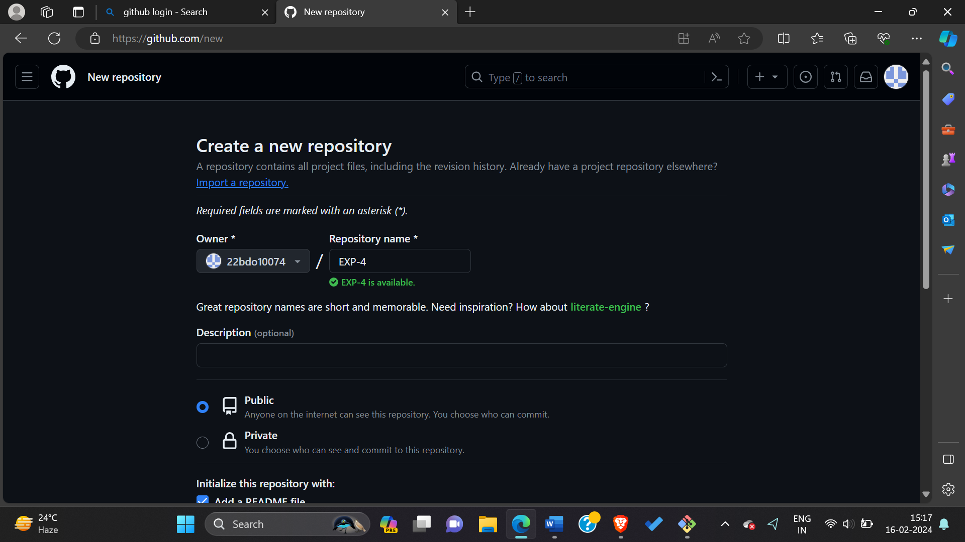

2. Initialize the git repository by using the command **$ git Init,** then we have to connect the local repository to the remote one using the command **git remote add origin”,** The next step is to connect the local repository to the remote repository using the following command.  
 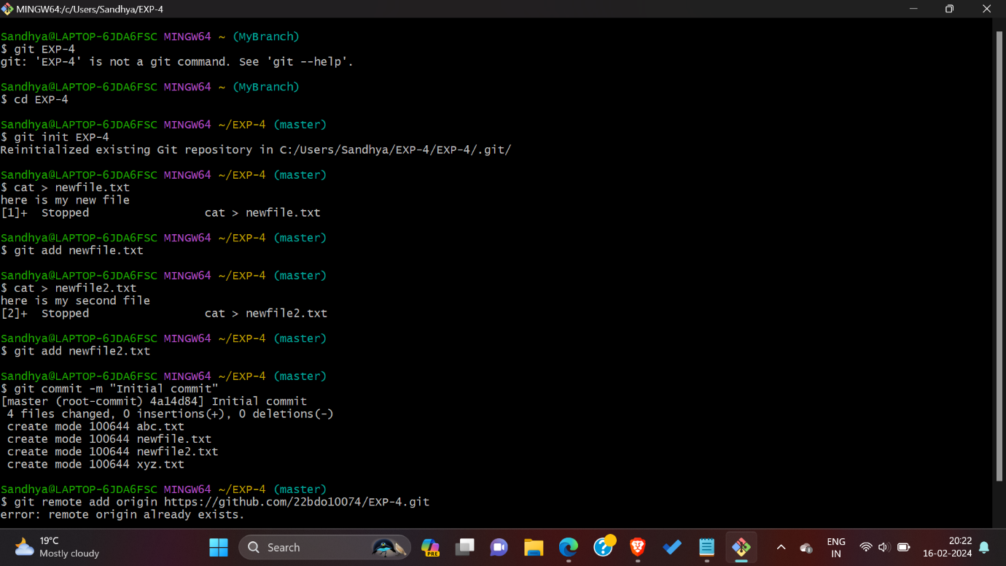  
3. Pull the main branch into the local machine.

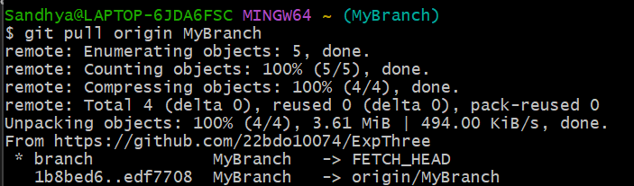

4. We have to bring two files in our local repository from the remote repository.



1. Showing all the content in this these files, using the cat command.

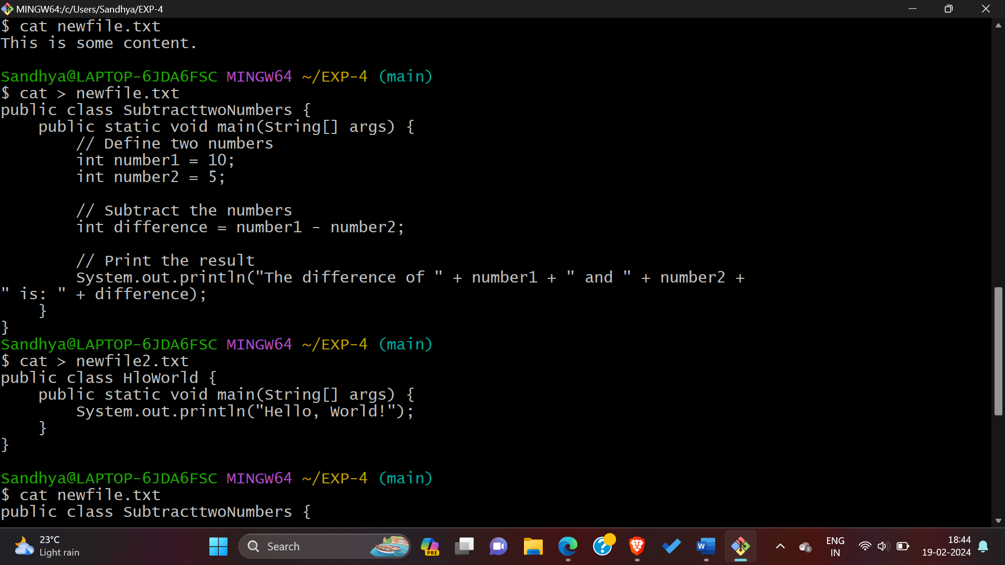

1. **Checking the content in the given two files by using cat command like** cat newfile.txt and cat newfile2.txt.

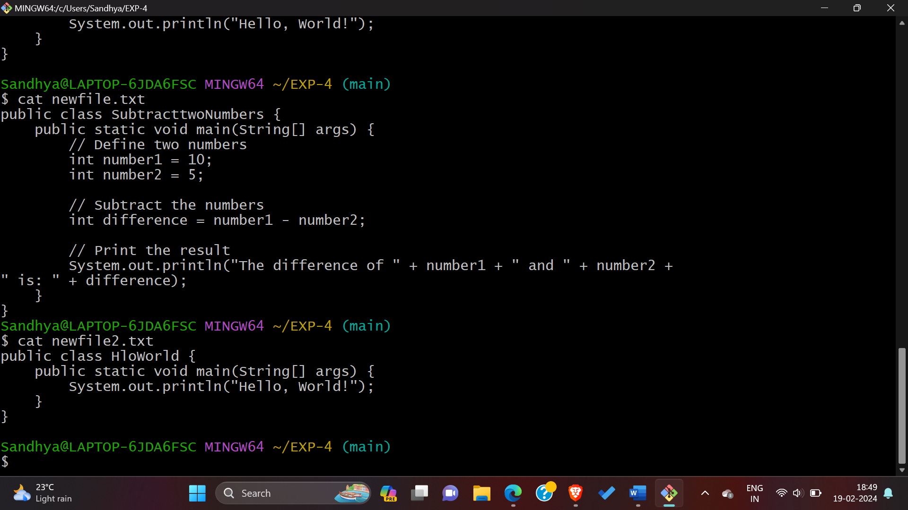

1. **In the text box, make any changes you need to both the file.**

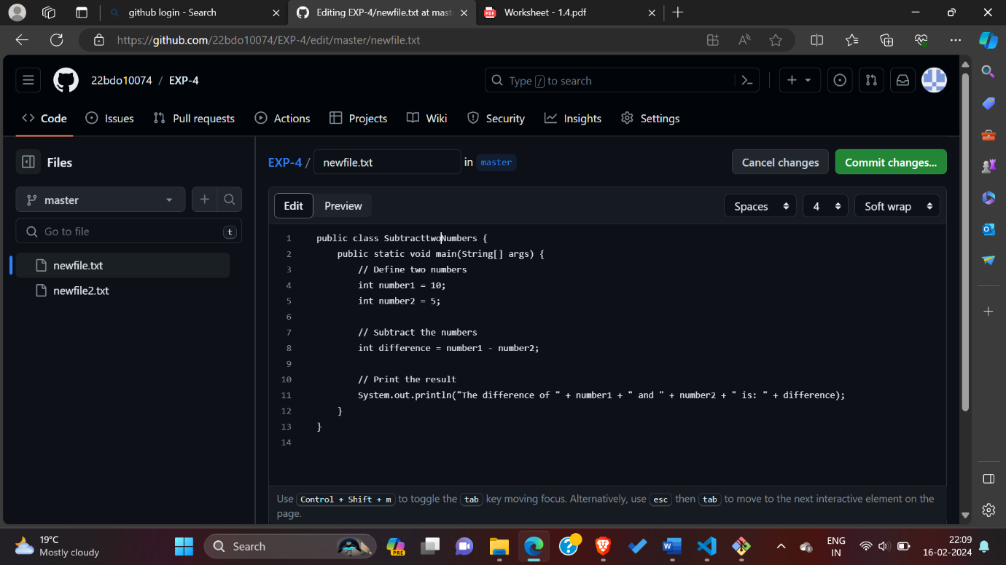

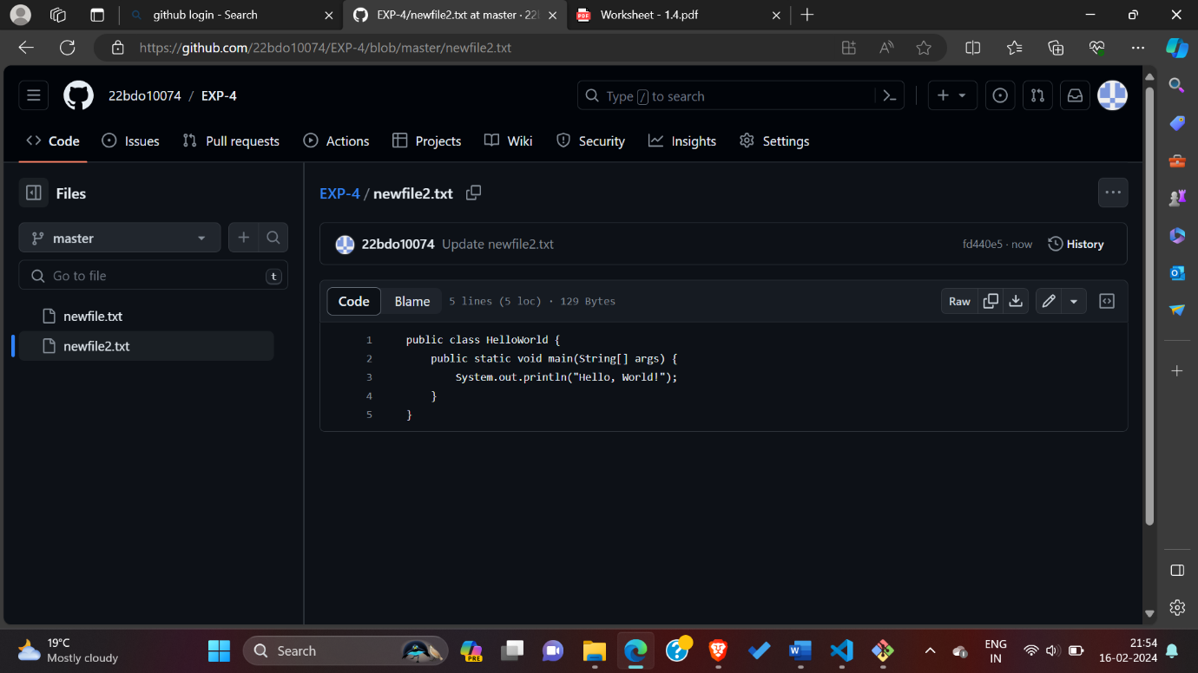

1. **Above the new content, click Preview and Click Commit changes for both the files.**

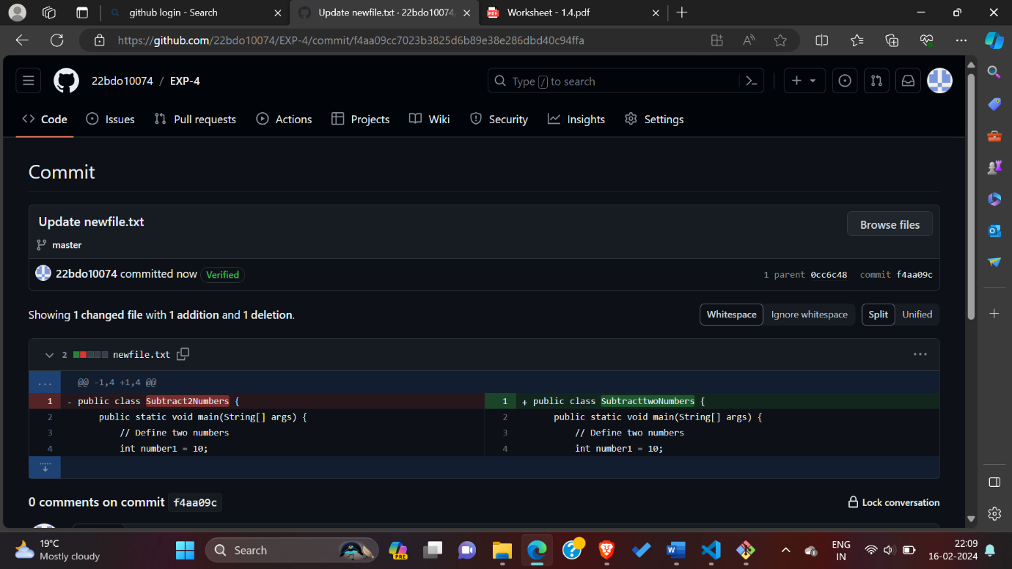

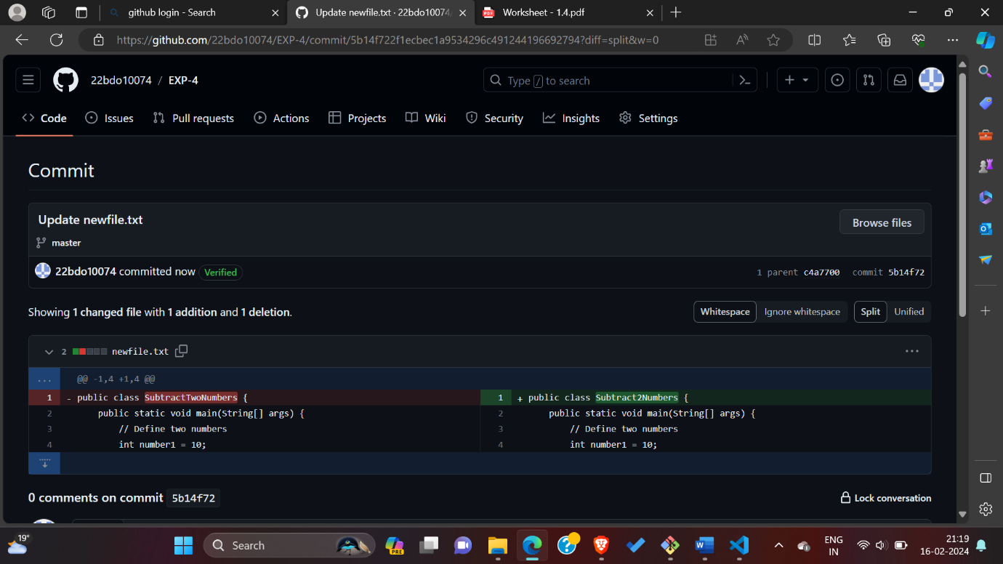

**8. compare and pull request, after that we will add any description then merge it.**

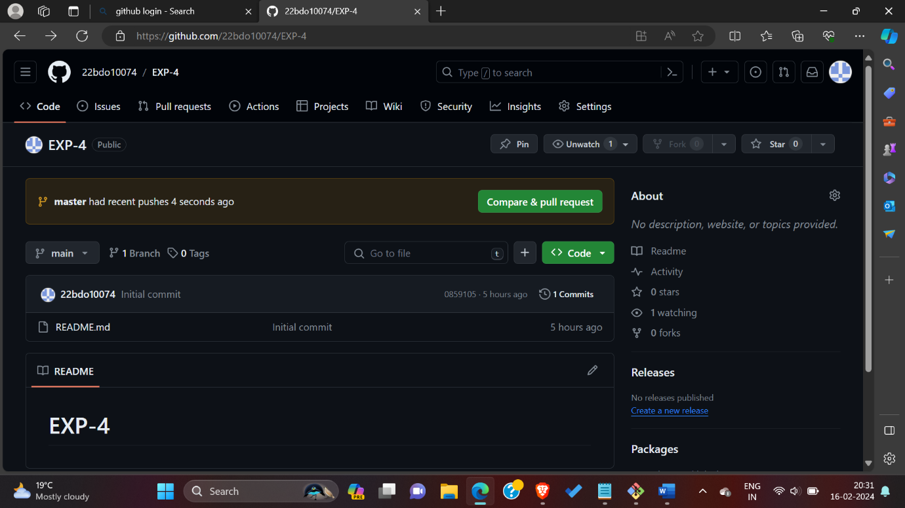

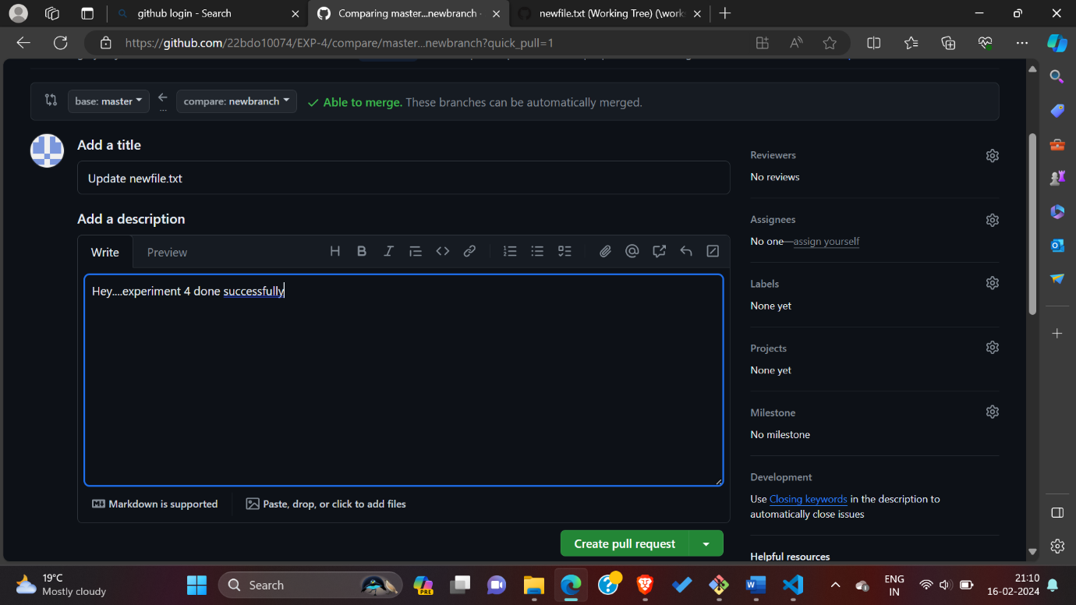

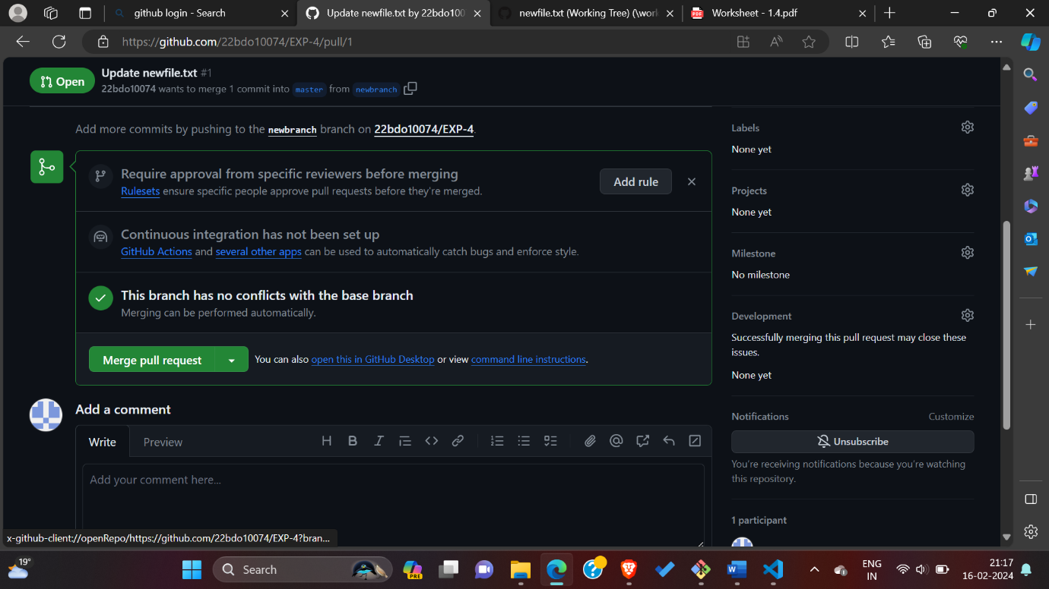

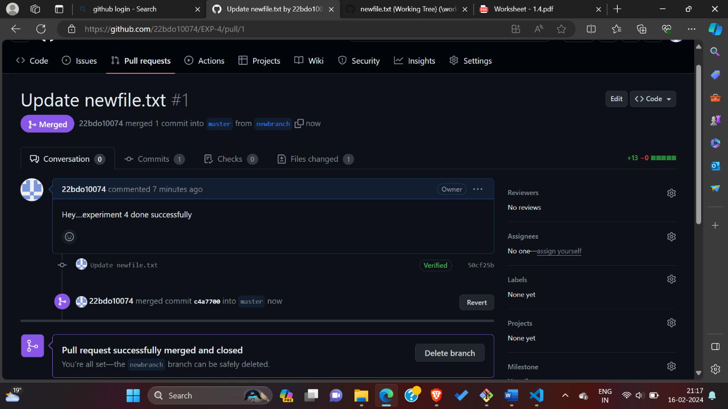

**9. In the "Commit message" field, type a short, meaningful commit message that describes the change you made to the file. You can attribute the commit to more than one author in the commit message.**

**10. Below the commit message fields, decide whether to add your commit to the current branch or to a new branch. If your current branch is the default branch, you should choose to create a new branch for your commit and then create a pull request.**

**11. Click Commit changes or Propose changes.**

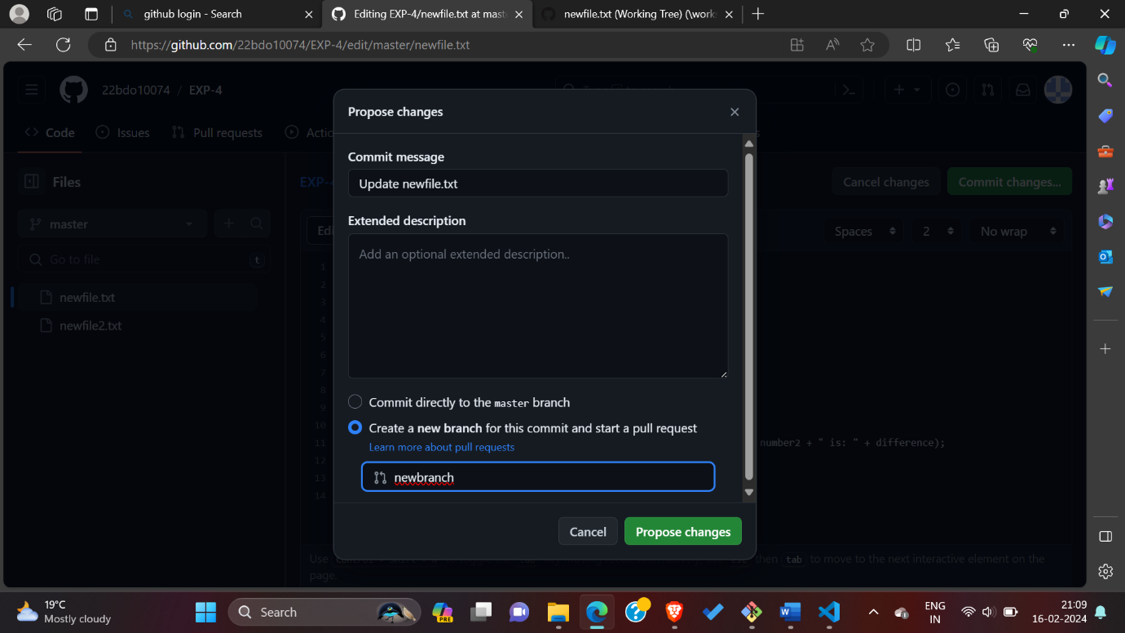

12. Now, we can see the remote repository is changed again.

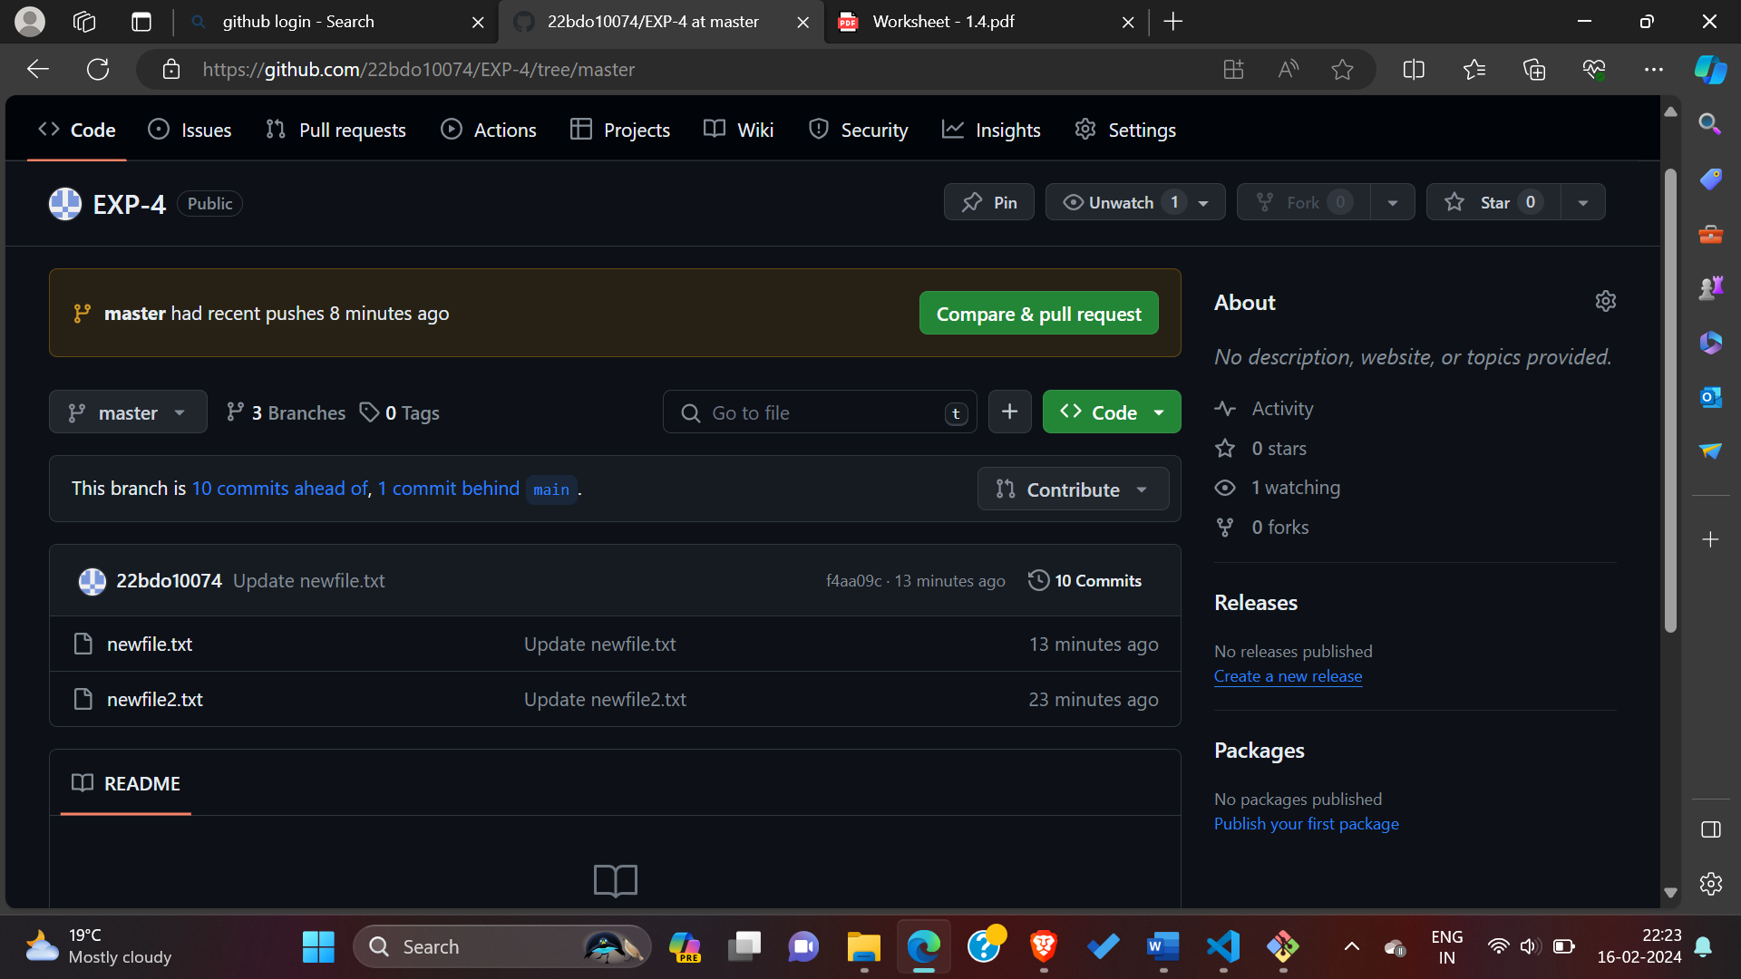

13. Here, all the commands that has been used in this experiment are as follows.

$ git Init (Git repository created)

$ cat newfile.txt (file created)

$ git status (to check status of all the files)

$ git add newfile.txt (add this file)

$ git commit -m “this newfile is commited" (file commited)

$ git add . (command essentially tells git to stage every updated file in this current folder and all subfolders as well).

$ git pull origin master (Pull changes from remote)

$ git push origin master (Push changes to remote)

$ git merge <branch_to_merge> (Merge branches)



1. **Result:** In this experiment, we have created one repository and added two files with some contents into it. After that, we have pulled and edited the files into the Git Bash, made some changes, then again pushed it to the remote repository, and observed the changes that are now merged.

# Learning outcomes (What I have learnt):

* 1. Understanding Git Workflow
  2. Understanding the difference between local and remote repositories.
  3. Pull and push commands
  4. Committing changes
  5. Working with staging area.

**Evaluation Grid (To be created as per the SOP and Assessment guidelines by the faculty):**

|  |  |  |  |
| --- | --- | --- | --- |
| Sr. No. | Parameters | Marks Obtained | Maximum Marks |
| 1. |  |  |  |
| 2. |  |  |  |
| 3. |  |  |  |
|  |  |  |  |